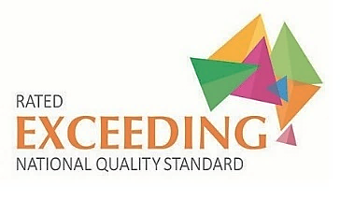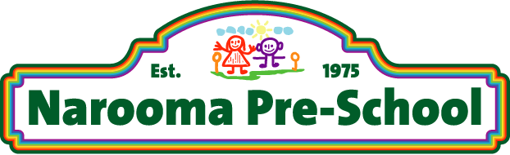

"Your Community Pre-School"

Information Booklet

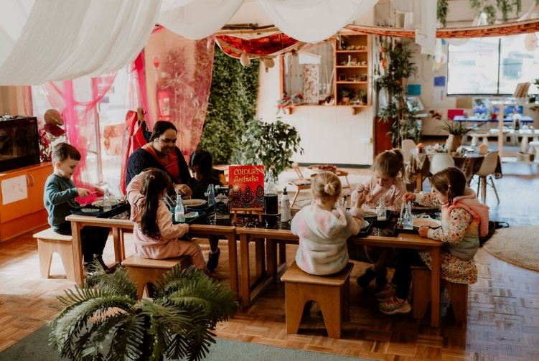

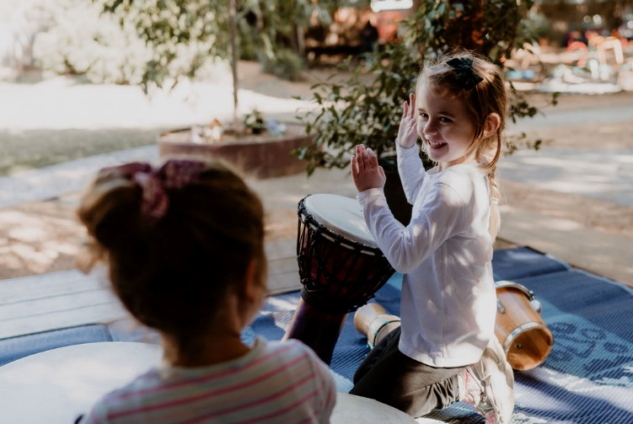

2 Nichelsen Street, Narooma  
PO Box 258, Narooma NSW 2546  
Ph: (02) 44762494

Email: [nar7895@bigpond.net.au](mailto:nar7895@bigpond.net.au)

Web site: [www.naroomapreschool.com.au](http://www.naroomapreschool.com.au)

*Member of Community Child Care Co-Operative NSW*  
Reg. Charity No.CFN 1197

**Welcome to Narooma PreSchool**

**Nominated Supervisor**: Kathy Phipps Teacher - Master of Education

**Teachers**: Chantelle Rogers and Laura Hackney (Job-Share) Bachelor of Early Childhood

**Educators**: Kate Heffernan – Diploma of Children’s Services

Cheryl Noonan – Diploma of Children’s Services (Working towards Teacheing Degree)

Teagan Nicholson – Certificate III in Childrens Services (Working towards Diploma)

Lee Coolimore – Dipolma of Children;s Services

Kellie Winter – Certificate III in Childrens Services

Talia Moreton- Stewart - Certificate III in Childrens Services

Emily Meredith – Support Educator

**Casual Educators**: Janet Linee - Certificate III in Childrens Services

**Administration Office** - Melanie Dollimore – Tuesday, *Wednesday* & Thursday (9:00 -3:00)

Narooma Preschool is the only community owned, non-profit Preschool in the area. All fees are used to operate and maintain the Preschool. We are licensed and funded by Department of Early Childhood Education NSW.

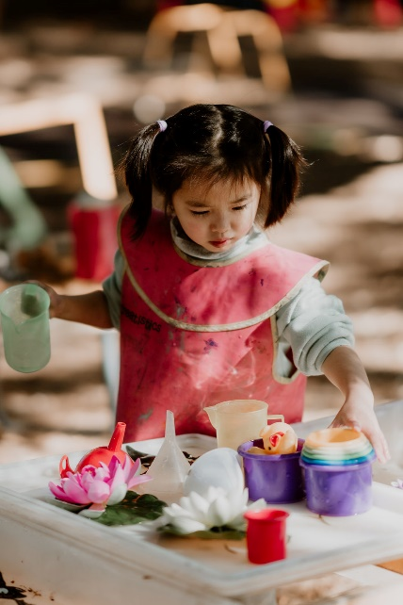

We embrace and value the diverse input we receive from all our families and community members.

We are committed to embedding the Aboriginal and Torres Strait Islander perspectives throughout our daily program to advance Reconciliation.

Play is the heart of our preschool philosophy.

Children’s interests and emerging ideas are the foundation of our play-based learning and its assessment.

We use both the Early Years Learning Frame work and the 8 Ways of Aboriginal Learning as a foundation to our educational program which is firmly based in current theoretical principles and practices.

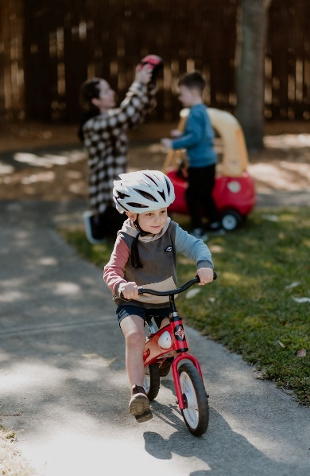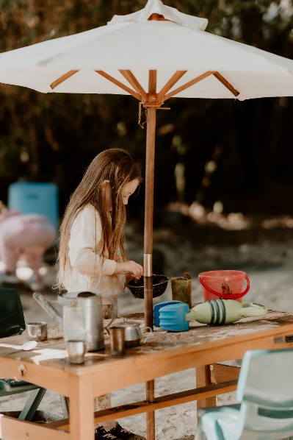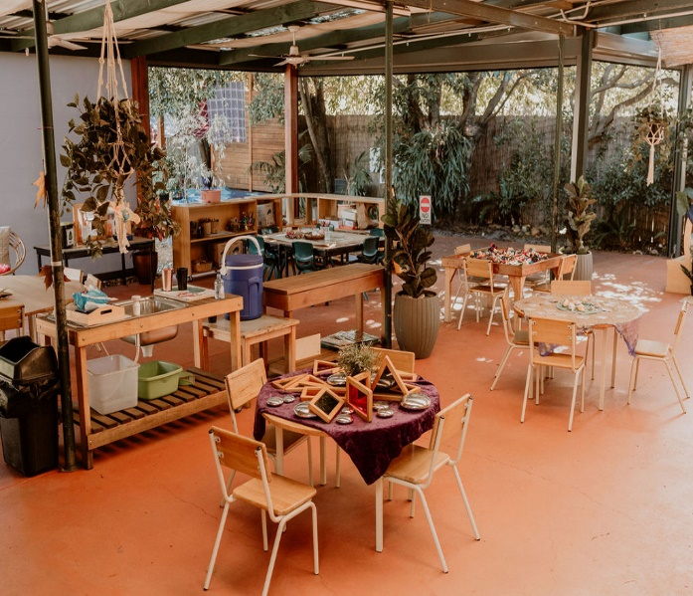

How to Enrol

We now complete all our enrolments online. If you have any concerns please come into our preschool office and we will assist you with your enrolment.

Please complete form in following link

<https://naroomaps.hubworks.com.au/>

*To place your child on the waitlist, select the WAITLIST icon on bottom right-hand corner (very faint)

We will contact you in November of the year before your child will start to attend our enrolment day.

*To enrol your child if instructed by Preschool select Enrol.

The form needs to be completed fully to enrol.

Please note: You will need to provide a copy of your child’s birth certificate

and immunisation from Medicare (Blue book is not sufficient). We need to keep a copy of these at the Preschool.

You will also be asked to sign a number of consent forms from the Department of Early Childhood Education NSW for us to complete our annual Census which allows the Preschool to receive our allocated funding and your choice of service parent payment funding.

Fees

Fees are payable for all sessions, including absences (excluding Public Holidays).

Guidelines and application forms are available.

Our Preferred Payment Method is Direct Deposit/Internet Banking

IMB Narooma BSB 641800 Account 200826874

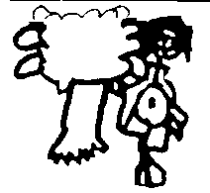Session Times

**All session times are from 8:00am – 3:30pm each day Monday through to Friday. We follow the school calender term and are closed during term break.**

*Please note* : All children must be signed in & out each day.

As staff are programming and setting up activities, please do not bring children before 8:00 am.

Any child picked up after 3:30 pm will incur a late collection fee of $30.00.

What to Wear

We encourage families to send their children in casual, comfortable, sun-safe clothes as some activities are messy (all our paints wash out in cold water). We want your child to feel free to engage in all the learning experiences without the fear of messing the clothing.

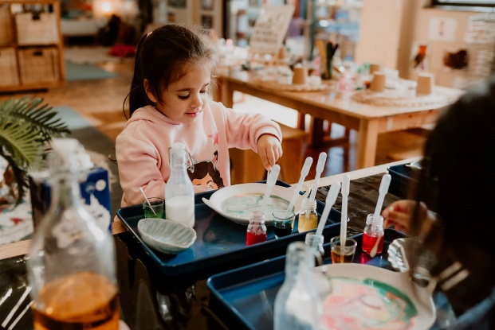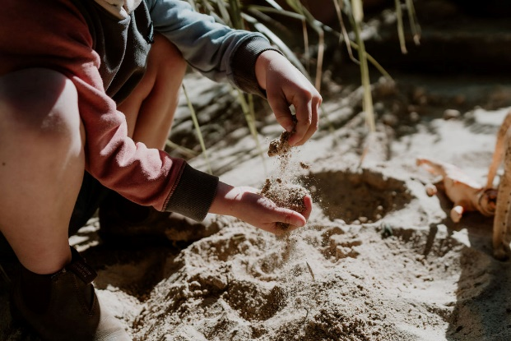

What to Bring

* A bag / backpack – containing jumper and change of clothes suitable for all kinds of weather.
* A sun-safe broad brimmed hat (NO baseball hats, please)
* A drink bottle with water.
* A lunchbox with a sandwich + fruit or yoghurt. Please limit choices - no chips, lollies, rollups, peanut products or chocolate please.
* Children **must** have sunscreen on September through May. (This is available at Pre-School)

**NB:** We have children with nut and egg allergies so enforce a

**“NUT & EGG FREE ZONE”**.

***Please label ALL your children’s belongings including shoes, socks, lunch containers, drink bottles and bags!***

**We are a Not-for Profit Community Preschool and are governed by our Model Constitution and Managed by a Preschool Committee formed by the families of the children in attendances at the preschool in any given year. We are in a wonderful community situation for our local children and their families to provide quality educational learning experiences in a culturally safe environment.**

**All funding and donations are poured back into the preschool for the maintenance and continuity of our preschool into the future.**

**The Policy Folder is available for you to read.**

**It is kept in the foyer area and are available on our WEBSITE.**

**Please don’t hesitate to speak to Kathy about any concerns regarding your child, or any issues relating to Narooma Preschool.**